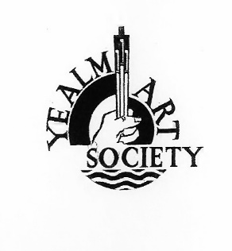

August 2022
Newsletter

Dear Members,
As the sun beats down and our lawns become more straw like, your committee has been looking ahead to September and the workshops, talks and painting together sessions for the Autumn.

Monday Painting Together Sessions Parish Room, Yealmpton
The members of the morning group have been painting en plein air over the summer but will now return to the Parish Room from September 5th - 10am to 1pm. £3 per session.
The attendance of the afternoon group was very patchy for May and June with no one at all turning up to paint on several occasions resulting in the sessions running at a loss. Therefore, it is with regret that we have decided not to book the room for the afternoons in September unless more members commit to coming along more regularly. There is no requirement to attend every week, but we do need a core of around five members each week to help cover the cost of the room.
Whether you were previously a member of the afternoon group or not, if you are interested in attending a Monday afternoon session, please contact
Maggie Nicholls Tel:881481 email: 1liam@gmail.com If enough members are interested these sessions can be restarted.

Thursday Painting Together Sessions Revelstoke Room, Noss Mayo
Many of the members who replied to the last newsletter were keen for these sessions to restart. We are pleased to announce that the room has been booked from
Thursday September 15th– 10am to 1pm. £5 per session incl. tea/coffee and biscuits.
The room hire fee is more expensive than in Yealmpton and this will be a trial. However, if it proves popular, with regular attendance, it will remain in the programme as before.
Please contact either Angela Macpherson angelamacpherson2@icloud.com or
Lin Forrester lin.f@btinternet.com if you are interested in joining this group (even if you are not available in September due to holidays etc.)

Workshops Comments Book
For future events there will be a comments book available for participants to record any comments about the event they may have - good or bad. Your comments can be anonymous.
This is to help the committee when deciding what artists to include in the next programme, and to bring to our attention to things we may have overlooked or could be done better.
Your comments will be appreciated.
Our next event is an evening talk and video presentation by
Ray Balkwill, entitled ‘An Artists View’ and ‘10 Top Tips for painting en plein air’
on Saturday 17th September at 7pm at the W.I. Hall, Newton Ferrers
Entrance Fee: £7.50 (to include a glass of wine and nibbles)
We are delighted to welcome Ray to talk about his artwork. He is an extremely popular and well-known artist whose artwork can be seen in many local galleries. He endeavors to capture the mood and ‘spirit’ of a place. His articles have been published in various art magazines.

This event is open to all, so please spread the word and feel free to bring friends and family.

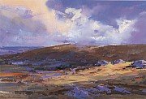
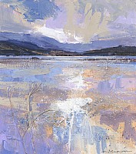
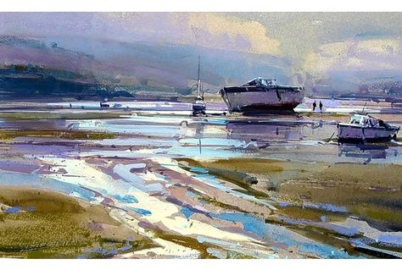
Artwork by Ray Balkwill https://www.raybalkwill.co.uk

Saturday Drawing Workshop by Anna Ventura - 24th September 10am to 4pm
At the Yealmpton Community Centre. Members £25 Non-members £30

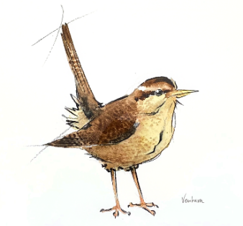
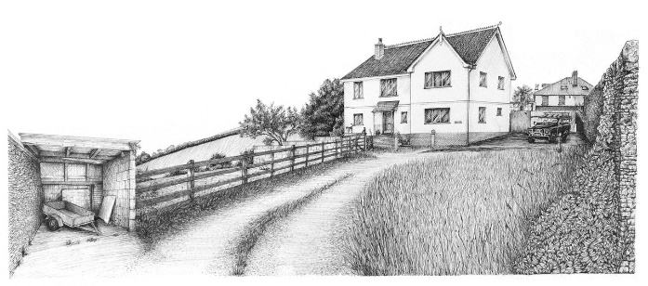
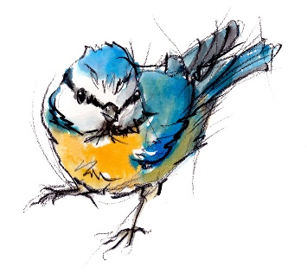
This workshop is suitable for all levels of experience. Maximum of 15 people.
Anna will be concentrating on sketching techniques, perspective, and volume, using different mediums such as charcoal, ink, brush etc. She will demonstrate and talk about techniques to draw effectively and loosen up.

The society will provide some materials for use on the day. Those who sign up will receive a full list of what to bring with them, for example, paper, watercolour brushes and paints, plus a wildlife image for practice of organic shapes and a street building image for perspective and lines.
Lin Forrester is taking the bookings for this workshop – please email lin.f@btinternet.com
Confirm how you will pay – either by BACS or Cheque
BACS - Yealm Art Society Account No. 01293696 Sort Code 30-96-68 Ref: Ventura
or by cheque made payable to the Yealm Art Society. Ref: Ventura and sent to
YAS Treasurer, Jane Gent, Ottawa, Crescent Rd., Ivybridge, Devon. PL21 0BP

Pop-Up Art Sale 29th October 10am to 4pm Noss Mayo Village Hall
Members will be invited to rent a table to display their artwork in any form, provided it is painted/constructed from scratch, such as paintings, drawings, collage. Mugs, key rings, coasters etc. displaying their artwork will also be accepted - but no items using pre-made constituents such as beads for jewelry etc. 12 tables will be available (these can be shared).
So basically, paintings or items displaying your paintings, but no crafts, or jewellery.
For those new to the Society, I thought it might be useful to introduce you to the committee and list their names and contact numbers.
You will notice we are still without a Treasurer, so if any members are handy with a spreadsheet, or know someone who is, please have a talk with Jane who is really the Membership Secretary!

Chairperson: Margaret Nicholls Tel: 881481 1liam@gmail.com
Secretary: Sue Denny Tel: 873157 sue.denny@talk21.com
Interim Treasurer: Jane Gent Tel: 895271 the.gents@ic24.net
Membership Secretary Jane Gent Details as above.
Publicity Secretary Angela Macpherson Tel: 872645 angelamacpherson2@icloud.com
Programme Secretary: Judith Mears Tel: 880282 judithmears@hotmail.com
Assisted by, Pammie Hall Tel: 892205 peahall56@yahoo.co.uk
Website and Exhibition Secretary Lin Forrester Tel: 872437 lin.f@btinternet.com

General Committee Member: Susannah Bradley Tel:07860555370 susannah@nossmayodesign.co.uk

That’s all for now, news about the October workshop with Anita Nowinska on the 15th October will be included in the next newsletter.

Sue Denny
YAS Secretary

